**Experiment No 9**

**Aim:**

To analyze competitor activities by extracting and interpreting social media and backlink data using the online SEO tool Backlinkr.net, with a focus on Steam and PlayStation websites.

**Software / Tool Requirements:**

| **Requirement** | **Description** |
| --- | --- |
| Tool | [https://www.backlinkr.net](https://www.backlinkr.net/) |
| Web Browser | Google Chrome / Mozilla Firefox / Edge |
| Internet Connection | Required |
| Spreadsheet Tool | (Optional) MS Excel / Google Sheets |
|  |  |

**Theory:**

In this practical, we conducted a comparative analysis of two major competitors in the gaming industry — Steam (store.steampowered.com) and PlayStation ([www.playstation.com](http://www.playstation.com/)) — using the SEO tool Backlinkr.net.

Competitor Analysis refers to identifying and evaluating the digital strategies used by rival companies to attract users and improve their online presence. This often involves analyzing:

* Backlinks: External links pointing to a competitor’s site.
* Anchor Texts: Keywords used in those links.
* Source Domains: Platforms linking to the competitor (blogs, forums, news sites, etc.).

Backlinkr.net helps uncover backlink profiles of competitors, allowing us to:

* Understand where their referral traffic is coming from.
* Discover their most popular content.
* Identify potential gaps and opportunities in our own strategy.

By analyzing Steam and PlayStation, we explored how gaming platforms attract attention, build domain authority, and maintain strong visibility through high-quality backlinks and content promotion.

**Procedure / Steps:**

1. Launch Tool:  
   Open your browser and go to [https://www.backlinkr.net](https://www.backlinkr.net/)
2. Enter Steam URL:  
   Type in [https://store.steampowered.com](https://store.steampowered.com/) and click "Get Backlinks." Observe the list of backlinks, domains, and anchor texts.
3. Analyse Steam's Results:  
   Identify high-authority domains linking to Steam. Take note of frequently linked pages (e.g., store page, game listings).
4. Enter PlayStation URL:  
   Type in [https://www.playstation.com](https://www.playstation.com/) and repeat the same process.
5. Compare the Two:  
   Use a spreadsheet (optional) to compare backlinks from both sites:

* Quantity and quality of backlinks
* Common anchor texts
* Top referring websites

1. Summarize Observations:  
   Highlight key insights such as which competitor has more gaming blog mentions, influencer backlinks, or news features.

**Output:** 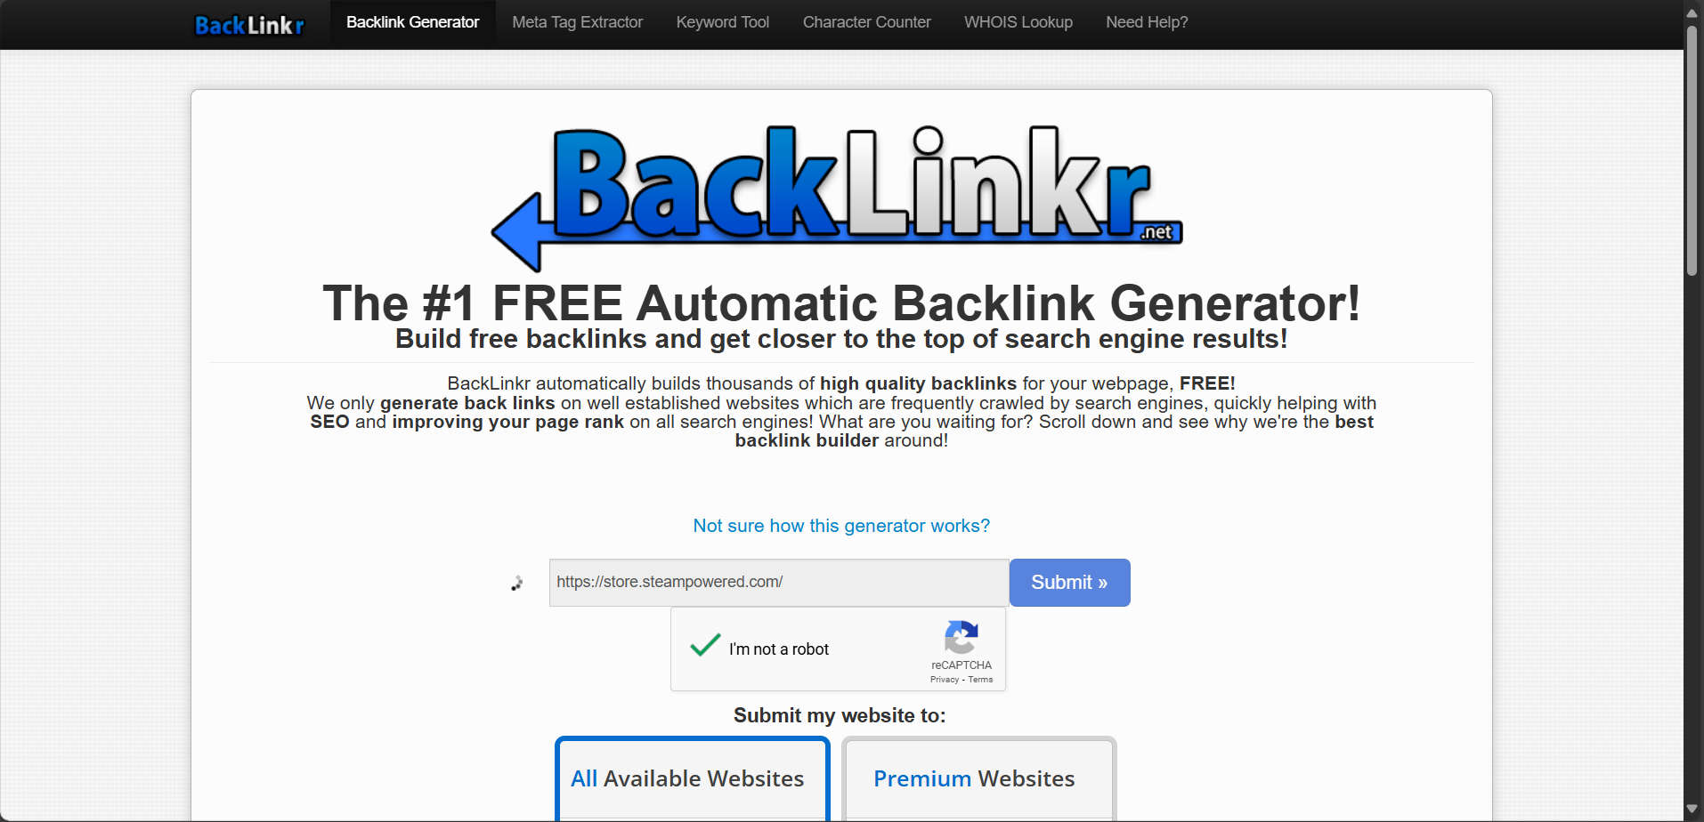

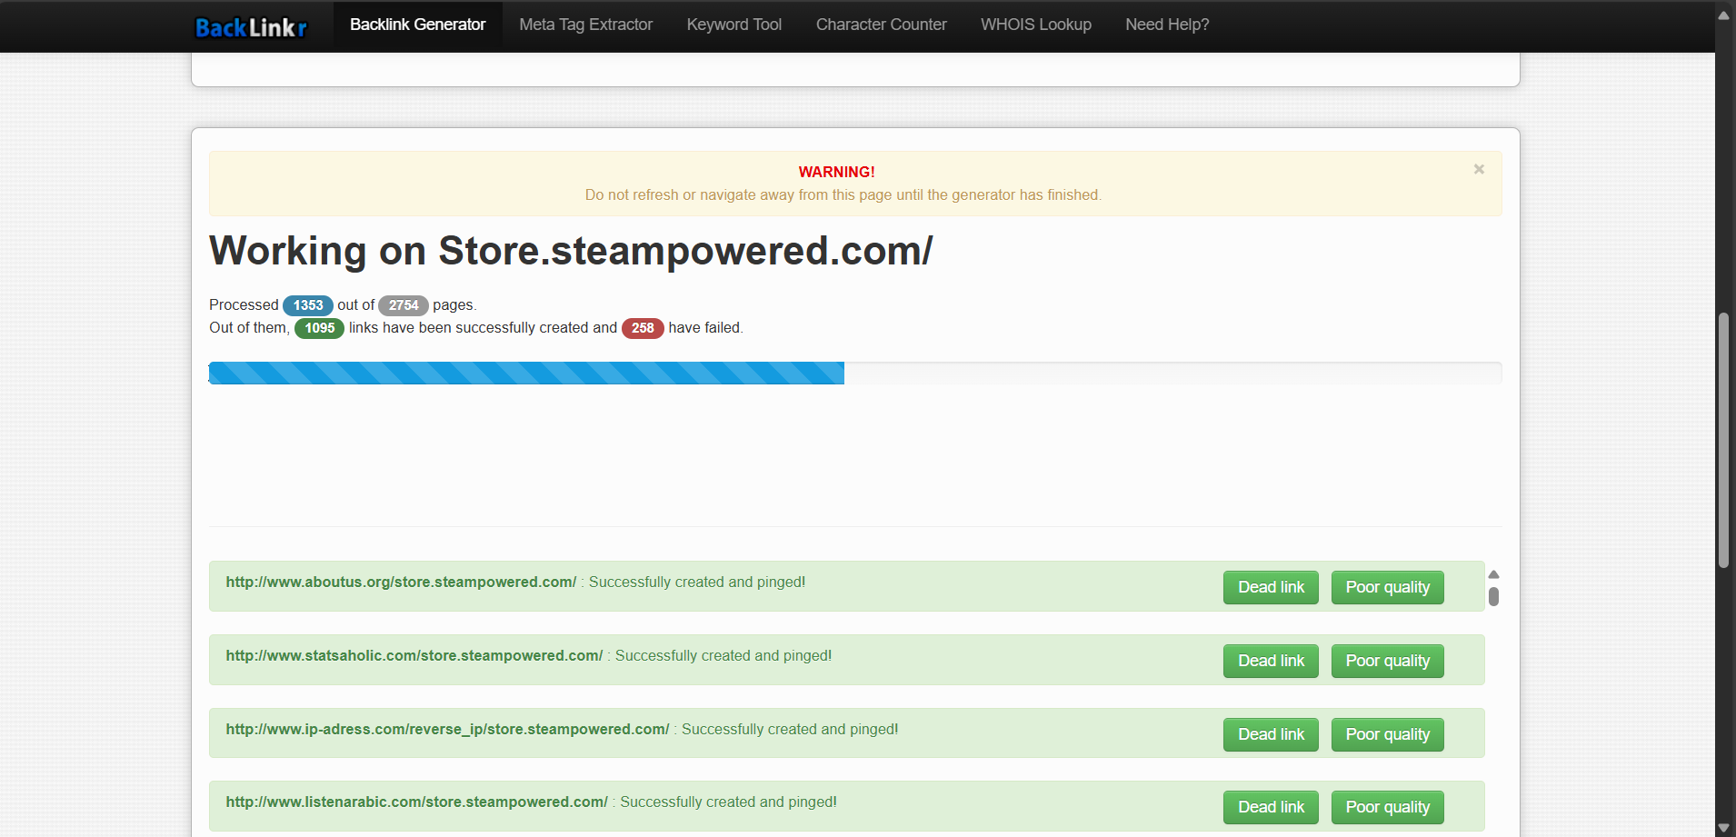

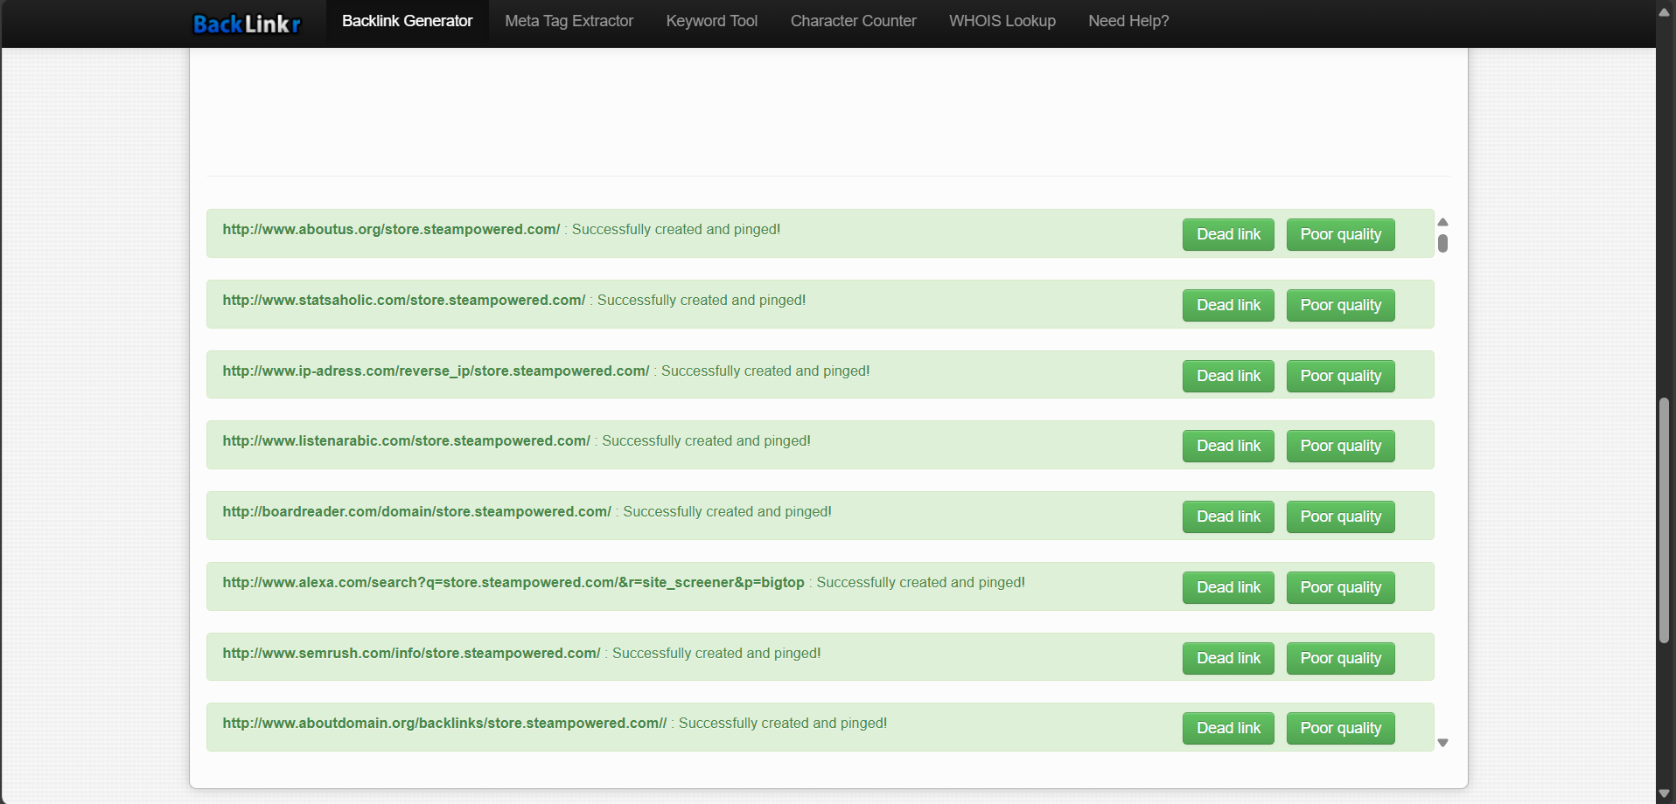

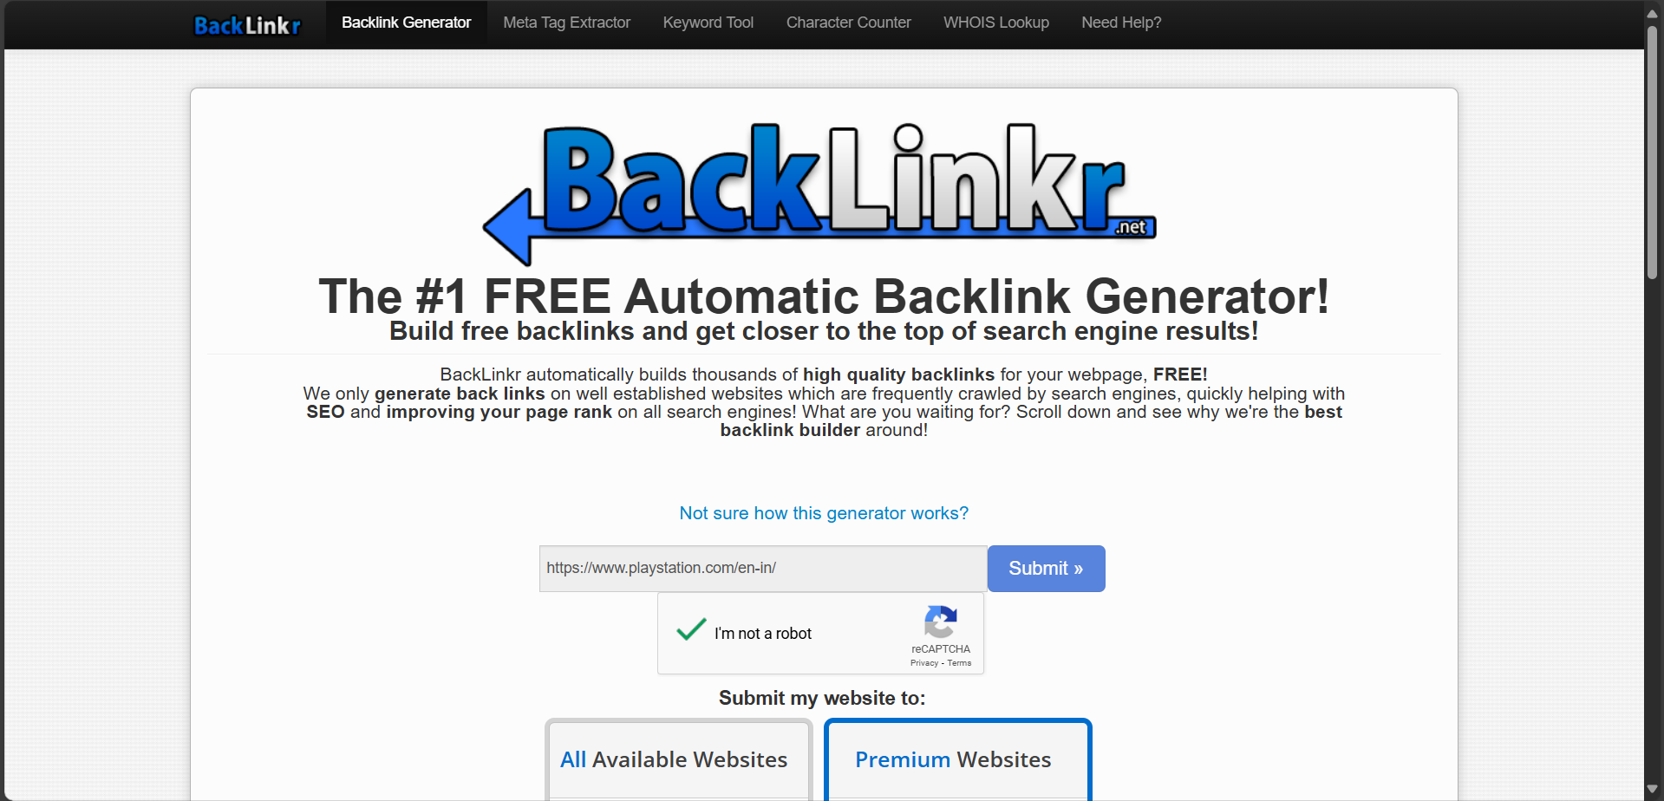

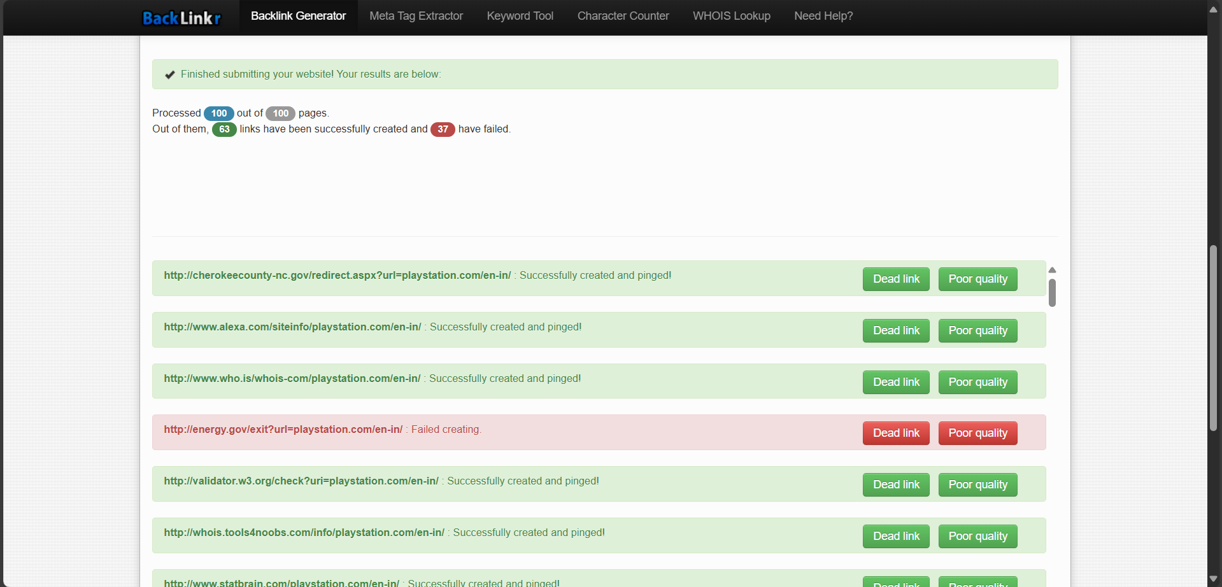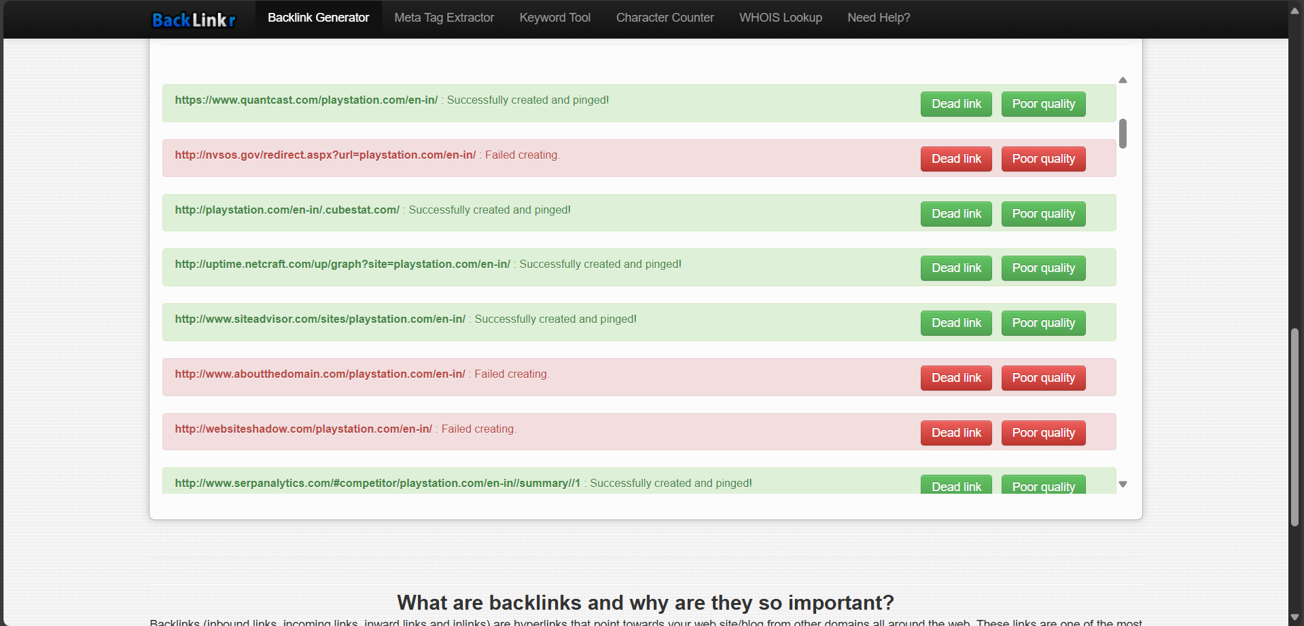

**Conclusion:**

Through the analysis of Steam and PlayStation using Backlinkr.net, we gained valuable insights into their backlink strategies and digital presence. Key takeaways include:

* Steam had a large number of backlinks from gaming forums and user-generated content platforms, showing strong community involvement.
* PlayStation had more backlinks from official tech blogs and news portals, indicating a focus on media partnerships and PR.
* Both platforms use strong, relevant anchor texts like "PS5", "Steam Sale", and "Exclusive Games", which helps boost their SEO rankings.

This competitor analysis helps us understand how major brands in the gaming industry attract backlinks and traffic, and how we can adapt similar techniques to enhance our own online strategies.